**Lab Report**

Title: Exploring Interpolation Methods on 30 day NDAWN Temperature Datasets in ArcGIS Pro

Notice: Dr. Bryan Runck

Author: Maisong Francis

Date: 4/22/2021

**Project Repository:** [*https://github.com/msongfrancis/GIS5572.git*](https://github.com/msongfrancis/GIS5572.git)

**Abstract**

<Delete this text in light grey throughout>

250 words max. Clearly summarize the following major sections. Each gets one or two sentences.

**Problem Statement**

Temperature data is dynamic and changes over time. NDAWN provides temperature data on the web for different temporal resolutions. To examine data on a monthly frequency, 30 days of temperature data must be extracted on the fly. Temperature data like maximum and minimum daily temperatures can also be extracted on the fly.Furthermore, NDAWN stations are dispersed unevenly. Temperatures in areas between station collection sites must be inferred through interpolation, which can be done with different methods.

Table 1. *Components needed to get NDAWN temperature data and interpolation analysis.*

|  |  |  |  |  |  |  |
| --- | --- | --- | --- | --- | --- | --- |
| **#** | **Requirement** | **Defined As** | **Spatial Data** | **Attribute Data** | **Dataset** | **Preparation** |
| 1 | NDAWN station information | Where NDAWN stations are located and their name. | Point geometry | Station lat and long |  | Extract lat long from html and create a table for each station |
| 2 | Temperature data | Average, minimum, and maximum daily temperature for the 30-day period for each NDAWN station |  | Average temp, minimum temp, maximum temp |  | Extract from NDAWN site |

**Input Data**

The information about the NDAWN stations and the daily temperature data can be extracted form the NDAWN website. The information was extracted from the CSV and HTML for each station.

Table 2. *Data needed to perform analysis.*

|  |  |  |  |
| --- | --- | --- | --- |
| **#** | **Title** | **Purpose in Analysis** | **Link to Source** |
| 1 | NDAWN stations coordinates | Used to create point features to show where stations are located. | [NDAWN](https://ndawn.ndsu.nodak.edu/) |
| 2 | Max daily temperature | Maximum daily temperature collected by each station. | [NDAWN](https://ndawn.ndsu.nodak.edu/) |
| 3 | Min daily temperature | Minimum daily temperature collected by each station. | [NDAWN](https://ndawn.ndsu.nodak.edu/) |
|  | Average daily temperature | Used to calculate the average 30-day temperature | [NDAWN](https://ndawn.ndsu.nodak.edu/) |

**Methods**

*Get NDAWN Data*

The station names and numbers were obtained by extracting the information from the HTML of the NDAWN website. Once the numbers were obtained, the URL for each station could be constructed and the coordinates for each station could be obtained once again from the HTML. The temperature data was obtained from the CSV for each station containing the daily average temperature, daily maximum temperature, and daily minimum temperature.

*Interpolating Maximum and Daily Temperatures*

A point feature class of the stations were created using the coordinates obtained. The temperature data was joined to the stations feature class and different interpolation tools, specifically IDW, Kriging, Raidal Basis Functions, and Empirical Bayesian Kriging, were used to interpolate the minimum and maximum temperatures for the data extent.

Figure 1. Data flow diagram to get 30-day NDAWN data and perform interpolation analysis in ArcGIS Pro.

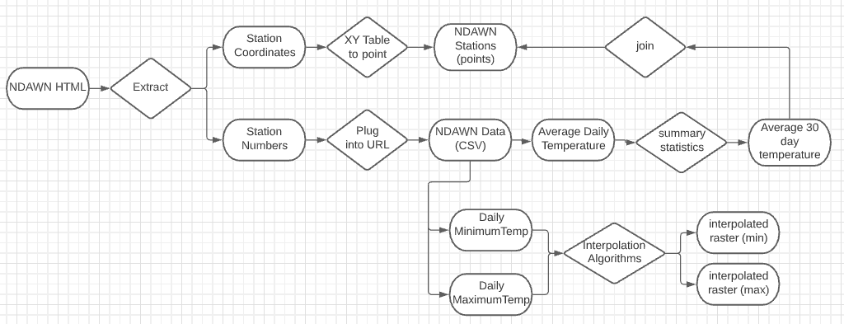

**Results**

Show the results in figures and maps. Describe how they address the problem statement.

Follow best practice for map design, coloring, etc.

**Results Verification**

I do not know that the result is correct because it is using different algorithms to interpolate maximum and minimum temperatures. One way to check the accurateness of a produced interpolated is to see how similar the values around each other are. Furthermore, you could test the interpolated results by removing a point and seeing if the interpolated results were like the temperatures collected.

**Discussion and Conclusion**

What did you learn? How does it relate to the main problem?

**References**

Use a common format

**Self-score**

Fill out this rubric for yourself and include it in your lab report. The same rubric will be used to generate a grade in proportion to the points assigned in the syllabus to the assignment.

|  |  |  |  |
| --- | --- | --- | --- |
| **Category** | **Description** | **Points Possible** | **Score** |
| **Structural Elements** | All elements of a lab report are included **(2 points each)**:  Title, Notice: Dr. Bryan Runck, Author, Project Repository, Date, Abstract, Problem Statement, Input Data w/ tables, Methods w/ Data, Flow Diagrams, Results, Results Verification, Discussion and Conclusion, References in common format, Self-score | 28 |  |
| **Clarity of Content** | Each element above is executed at a professional level so that someone can understand the goal, data, methods, results, and their validity and implications in a 5 minute reading at a cursory-level, and in a 30 minute meeting at a deep level **(12 points)**. There is a clear connection from data to results to discussion and conclusion **(12 points)**. | 24 |  |
| **Reproducibility** | Results are completely reproducible by someone with basic GIS training. There is no ambiguity in data flow or rationale for data operations. Every step is documented and justified. | 28 |  |
| **Verification** | Results are correct in that they have been verified in comparison to some standard. The standard is clearly stated **(10 points)**, the method of comparison is clearly stated **(5 points)**, and the result of verification is clearly stated **(5 points)**. | 20 |  |
|  |  | 100 |  |